RATE MONOTONIC SCHEDULING
#include <stdio.h>

struct task {
int id;
int cpu;
int period;
};

void monotonic_scheduling(struct task t[], int n, int max_time) {
for (int i = 0; i < n; i++) {
printf("Task %d:\n", i + 1);
printf("Id: "); scanf("%d", &t[i].id);
printf("Cpu time: "); scanf("%d", &t[i].cpu);
printf("Period: "); scanf("%d", &t[i].period);
}

for (int i = 0; i < n; i++)
for (int j = 0; j < n - i - 1; j++)
if (t[j].period > t[j+1].period) {
struct task temp = t[j]; t[j] = t[j+1]; t[j+1] = temp;
}

int remaining_time[n], next_arrival[n], next_deadline[n];
int timeline[max_time], deadline_miss[max_time];

for (int i = 0; i < n; i++) {
next_arrival[i] = t[i].period;
next_deadline[i] = t[i].period;
remaining_time[i] = t[i].cpu;
}

for (int time = 0; time < max_time; time++) {
deadline_miss[time] = 0;

for (int i = 0; i < n; i++) {
if (time == next_deadline[i]) {
if (remaining_time[i] > 0) {
printf("Deadline Miss! T%d at time %d\n", t[i].id, time);
deadline_miss[time] = 1;
}
next_deadline[i] += t[i].period;
}
}

for (int i = 0; i < n; i++) {
if (time == next_arrival[i]) {
remaining_time[i] = t[i].cpu;
next_arrival[i] += t[i].period;
}
}

int current_task = -1;
for (int i = 0; i < n; i++) {
if (remaining_time[i] > 0) {
current_task = i;
break;
}
}

if (current_task != -1) {
timeline[time] = t[current_task].id;
remaining_time[current_task]--;
} else {
timeline[time] = 0;
}
}

printf("\nGantt Chart:\n");
for (int time = 0; time < max_time; time++) {
if (timeline[time] == 0)
printf("|%-6s", "Idle");
else {
char buf[8];
sprintf(buf, " T%d ", timeline[time]);
printf("|%-6s", buf);
}
}
printf("|\n");
for (int time = 0; time <= max_time; time++)
printf("%-7d", time);
printf("\n\n(* = deadline miss)\n");
for (int time = 0; time < max_time; time++)
printf("%-7s", deadline_miss[time] ? "*" : " ");
printf("\n");
}

int main() {
int n, max_time;
printf("Enter number of tasks: "); scanf("%d", &n);
printf("Enter simulation time: "); scanf("%d", &max_time);
struct task t[n];
monotonic_scheduling(t, n, max_time);
return 0;
}
OUTPUT:

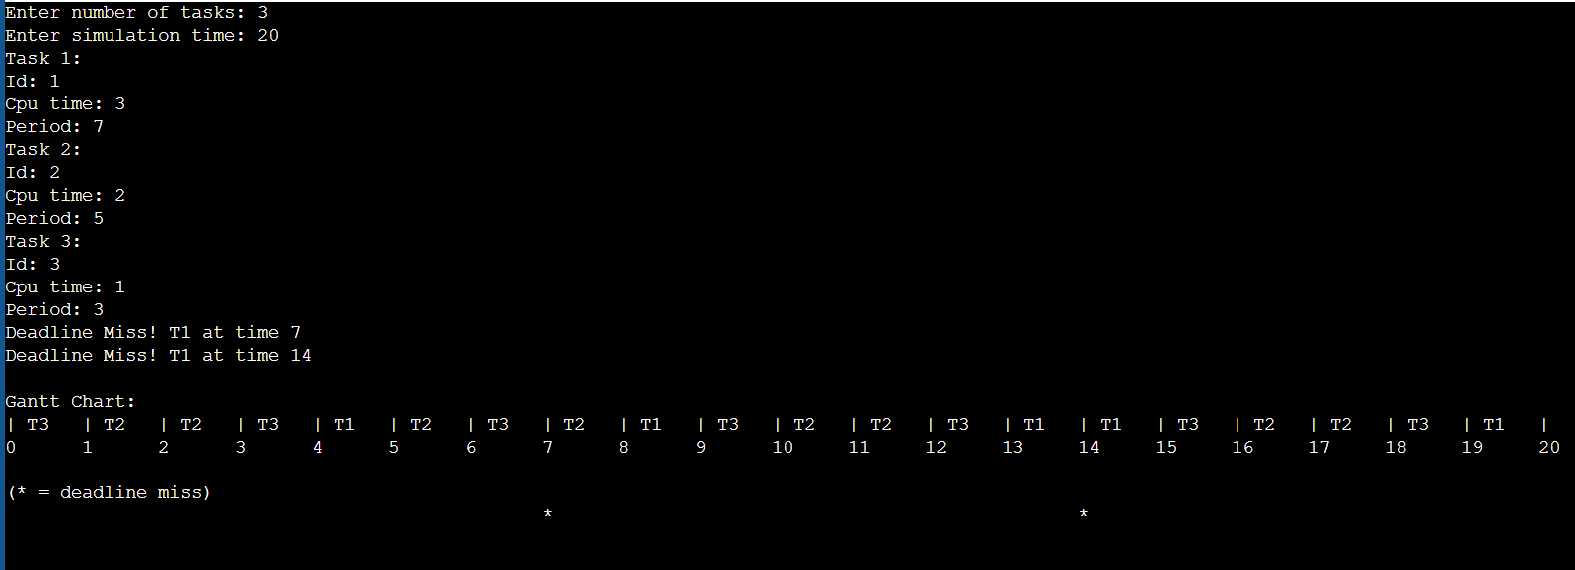
OBSERVATION BOOK:

